Description on how to download Intraday Data from Alpha Vantage:

Alpha Vantage provides APIs to fetch time series data for stocks as well as physical and digital/crypto currencies. Time series data include intraday data with time intervals 1min, 5min, 15min, 30min and 60min. Yahoo symbols for stocks and indices on most exchanges world-wide can be used with Alpha Vantage APIs. That makes it convenient and need not search for symbols for use on Alpha Vantage.

Users will need to get an API key from Alpha Vantage (https://www.alphavantage.co/) first. Unfortunately the free API key only allows making 5 requests / minute (https://www.alphavantage.co/support/#api-key). If you need to make more frequent requests, please upgrade your API key (https://www.alphavantage.co/premium/).

Please also refer to the “Alpha Vantage API Documentation” to understand what and how data can be downloaded. One key point to note: By default, outputsize=compact. Strings compact and full are accepted with the following specifications: compact returns only the latest 100 data points; full returns the full-length time series of around 5 days. The "full" option is recommended for intraday data download, but note that for 1min data, each ticker can take 30 seconds or so. Note that this is ok for free API key which allows only 1 download request per 12 seconds (or 5 requests/min) anyway.

Set-up:

- Copy the following line and append to your existing “mywebserver.txt. If your portfolio name is “Google_I5.tic’, change <your-portfolio-name> to Google_I5. The interval parameter also needs to be changed to match the interval for this portfolio.

<your-portfolio-name>, https://www.alphavantage.co/query?function=TIME_SERIES_INTRADAY&symbol=SSSS&interval=5min&outputsize=full&datatype=csv&apikey=<your-personal-API-key>,I1,alphavantage_I1(csv).fmt

- Copy the supplied “alphavantage_I1(csv).fmt” file to the “fmt” subfolder under the Data File Location (indicated on the Preference screen).

- Run HSQuote Plus and use the same ticker symbols as on Yahoo Finance, including world-wide exchanges.

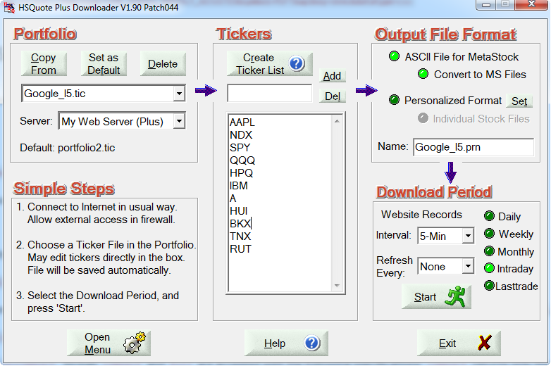

Backfilled Intraday Data Download:

For the first time download, you may click on the “Daily” option, and change the Fr. Date to about 10 days back, and then switch back to the “Intraday” option. This will allow capturing up to about 5 days of backfilled intraday data from Alpha Vantage.

HSQuote program will keep track of the last successful data date. You don’t need to indicate the starting period of the date range. Just leave the Intraday option selection, and click the Start button to download data.

